Audit Conclusion

17/09

Construction activities performed for the repair, modernisation and development of a network of class II and class III roads in the territory of selected regions, co-financed by the European Union and national resources

The audit was included in the audit plan of the Supreme Audit Office (hereinafter the “SAO”) for 2017 under number 17/09. The audit was headed and the Audit Conclusion drawn up by the SAO member Ing. Jan Málek.

The purpose of the audit was to verify whether the repairs, modernisation and development of class II and class III roads were executed economically, efficiently and effectively, and whether the rules and conditions for the use of the EU funds and national resources were observed.

Subject to audit was the period from 2014 until 2016; for factual contexts, also the preceding and subsequent periods were included. The audit was conducted with the auditees between February 2017 and August 2017.

Auditees:
State Fund for Transport Infrastructure, Prague (hereinafter “SFDI”); Regional Council of the Southwest Cohesion Region, České Budějovice (hereinafter “RCSW”); South Bohemian Region, České Budějovice (hereinafter “SBR”); Liberec Region, Liberec (hereinafter “LR”); Moravian-Silesian Region, Ostrava (hereinafter “MSR”); Pardubice Region, Pardubice (hereinafter “PR”); Road Management of the Moravian-Silesian Region, public-benefit corporation, Ostrava (hereinafter “RMMSR”); Road Management and Maintenance of the Pardubice Region, public-benefit corporation, Pardubice (hereinafter “RMMPR”); Road Management and Maintenance of the Pilsen Region, public-benefit corporation (hereinafter “RMMPilR”).

The objections to the audit protocol submitted by the auditees – the SFDI and the RCSW – were dealt with by the heads of the groups of auditors by a decision on objections. The auditees did not lodge any appeal against the decision on objections.

The Board of the SAO at its II. meeting held on 19 February 2018
approved by Resolution No. 9/II/2018
the audit conclusion in the following wording:
I. Introduction

The SAO audited the provision, drawing and use of the European Union (hereinafter the “EU”) funds and state funding for construction activities undertaken to repair, modernise and develop a network of class II and class III roads in the territory of selected regions (hereinafter the “regional roads”).

SFDI

The SFDI was established by Act No. 104/2000 Coll. with effect from 1 July 2000. The SFDI is an accounting and legal entity under the authority of the Ministry of Transport. The purpose of the SFDI is to finance the construction, modernisation, repair and maintenance of roads and motorways, national and regional railways, major inland waterways and airport equipment to the extent specified by law. The SFDI concludes agreements with the beneficiaries of the funds and is responsible for ensuring an effective use of the funds according to the approved SFDI budget. It is authorised to audit the use of the funds by the beneficiaries and take the necessary measures to ensure the expected effectiveness.

Pursuant to Act No. 132/2000 Coll., class II and class III roads have been owned by the regions in whose territories these roads are located since 2001. These roads remain part of the road system within the meaning of Act No. 13/1997 Coll. and their public character, which is also decisive for their funding system, is still preserved. For this reason, these roads are also the object of SFDI financing, as is apparent from the purpose for which the SFDI was established.

From 2015, the SFDI provided part of the available funding from its budget to finance repairs, reconstruction and modernisation of regional roads. To this end, it reserved for the years 2015 and 2016 a part of its budget totalling CZK 7.4 billion.

Regional Operational Programmes

In the Czech Republic, there were a total of 7 Regional Operational Programmes (hereinafter “ROP”), which in the 2007-2013 programming period served to support the economic and social development. The ROP were approved by the European Commission. The Programmes used subsidies from the European Regional Development Fund to aid projects implemented in the territory of the Cohesion Regions.

The ROP included priority axes dividing the Operational Programme into logical units. These logical units were further concretised through the so-called areas of support. The areas of support defined what types of projects could be approved within the priority axis.

The Regional Council of the Cohesion Region (also referred to as the “RC”) is, within the meaning of Section 16 of Act No. 248/2000 Coll., the managing authority for the ROP and is an accounting entity. The management of the RC is determined by Act No. 250/2000 Coll. The governing body of the Regional Council is the President of the RC. The executive body of the RC is the Regional Council Authority, which provides for tasks related to the ROP Managing Authority.

The Regional Council of the Southwest Cohesion Region announced the last call for projects under the area under review in May 2014, with the projects having to be physically implemented by 30 July 2015 at the latest. EU funding through the ROP had been completed. The RCSW then carried out only monitoring in connection with ensuring the sustainability of the projects.

Beneficiaries of subsidies

Beneficiaries of the subsidies were either regions or their public-benefit corporations, set up to manage and maintain regional roads.

In particular, the audit examined whether the repairs, modernisation and development of the class II and class III roads had been efficient, effective and economic (hereinafter “3E”). At the same time, compliance with legislation related to the audited issue was verified.

The SAO audited two fund providers – the SFDI and the RCSW – and 7 beneficiaries, examining 39 projects in the total financial volume of CZK 741,323,197.

The audit of the SAO also revealed the share of financial resources of some regions in the financing of repairs, modernisation and development of class II and class III roads but it could not verify this information because the SAO’s competence does not allow for the verification of the financial management of the regions.

Comparison of some parameters from similar audits

The SAO took advantage of the fact that the Supreme Audit Office of the Slovak Republic (also referred to as the “SAO SR”) had carried out an audit in 2014 focused on the processes related to the maintenance, repair and development of networks of class II and class III roads managed by higher territorial self-governing units in Slovakia (hereinafter “HTU”). The audit results were published in the Summary Report entitled “Summary report on the outcome of the audit of the economy, efficiency and effectiveness of the funds spent on the construction, repair and maintenance of the roads managed by HTU and the tasks resulting for the HTU therefrom” (hereinafter the “Summary Report”), and some of the findings were compared with the results of Audit No. 17/09.

The comparison showed a different involvement of sources of funds and a different average cost of 1 km of reconstructed class II and class III roads. While the lower threshold of the price range of the offered prices per 1 km is comparable in both cases, the upper threshold was more than double for Czech beneficiaries.

The main source of funding for the maintenance, repair and development of networks of class II and class III roads in the Slovak Republic is the tax revenue from motor vehicles, which is the income of individual regions. The use of these funds is subject to audit by the SAO SR.

More detailed information on the results of the audit of the SAO SR and their partial comparison with the results of Audit No. 17/09 are given in Annex 1.

Note: The legal regulations contained in this Audit Conclusion are applied in the version effective for the period under review.

II. Summary and evaluation of facts found during the audit

The financing of repairs, modernisation and development of class II and class III roads under the SFDI, unlike the EU funding method, was a non-systemic solution initially designed for one year.

The audit did not prove that the funds in the audited sample had been spent ineffectively. In some cases, however, the projects lacked objectively measurable and verifiable goals. Beneficiaries of the subsidies in most cases complied with the rules and conditions for the use of the EU and national funds.

The SFDI did not set specific measurable objectives as part of the financing of repairs, modernisation and development of class II and class III roads, only defined the purpose of the financing, which was the repair, reconstruction and modernisation of these roads. The SFDI did not evaluate the overall contribution of the funding, the scope of class II and class III roads quality improvement or the effectiveness of the implemented actions.

Beneficiaries of the subsidies did not systematically evaluate the unit costs for the repairs, modernisation and development of class II and class III roads. The auditees had not created a reliable and effective tool for assessing the expected values of public contracts. Determining the expected values of public contracts was left to the external providers of project documentation, and the auditees did not verify how realistically the expected value of the contract had been determined.

Cases of a large decline in bid prices over the projected public contract values do not necessarily mean an economical use of funds, but may also point to an incorrectly stated amount of the expected value of the public contract.

Identified risks

- Financing of repairs, modernisation and development of class II and class III roads may continue in a non-systemic way in the years to come, as the state’s funding in this area has not yet been fully assessed and defined.

- Lack of funds after the end of the 2014-2020 programming period may create additional pressure on non-systemic solutions.

III. Details of the findings

1. Evaluation of the procedure of subsidy providers

1.1 SFDI

1.1a Funding decisions, justifications, background

From 2015, the SFDI provided part of the available funding from its budget to finance repairs, reconstruction and modernisation of regional roads. Beneficiaries of the funds were regions or authorities for road management and maintenance set up by the regions (hereinafter “RMM”), or authorities for road management (hereinafter “RM”). From the assessed variants of allocation of funds to the individual regions, the variant according to the length of class II and class III roads in the region was chosen.

The CDP CR decided on the funding of regional roads from the SFDI budget in the years 2015-2017. The SFDI Committee allocated an amount according to the balance of available funds in the SFDI budget approved by the CDP CR. From its budget, the SFDI approved an allocation of CZK 4.4 billion in 2015 and CZK 3 billion in 2016 for the financing of regional roads. For the year 2017, an allocation of CZK 2.4 billion was approved on the condition of settlement of the SFDI receivables in the amount required to cover this budget measure. In 2018, according to the SFDI, with regard to the defined expenditure frameworks, the financing of regional roads is not foreseen.

An overview of allocated funds to the individual regions from the SFDI budget and their drawing in 2015 and 2016 is given in Table 1:

Table 1 – Overview of funding from the SFDI budget for class II and class III roads owned by regions and its drawing in 2015 and 2016 (in CZK)
Regions of the Czech Republic | Funds 2015 |  | Funds 2016
 | Allocated | Drawn | Allocated | Drawn
Central Bohemian Region | 778,800,000 | 777,815,324 | 531,596,000  984,675* | 531,596,000  984,675*
South Bohemian Region | 492,360,000 | 492,360,000 | 335,874,000 | 335,874,000
Pilsen Region | 415,800,000 | 393,958,348 | 283,703,000  21,411,327* | 283,703,000  21,411,327*
Karlovy Vary Region | 164,560,000 | 164,560,000 | 112,188,000 | 112,188,000
Ústí Region | 330,000,000 | 330,000,000 | 225,016,000 | 225,016,000
Liberec Region | 187,440,000 | 187,440,000 | 127,894,000 | 127,894,000
Hradec Králové Region | 299,200,000 | 294,284,683 | 203,649,000 | 203,649,000
Pardubice Region | 282,920,000 | 282,920,000 | 192,864,000 | 192,864,000
Vysočina Region | 412,280,000 | 412,280,000 | 281,049,000 | 281,049,000  -12,071,173**
South Moravian Region | 349,800,000 | 349,800,000 | 238,475,000 | 238,475,000
Olomouc Region | 279,840,000 | 279,567,390 | 190,530,000 | 190,528,326
Zlín Region | 159,720,000 | 159,720,000 | 108,745,000 | 108,745,000
Moravian-Silesian Region | 247,280,000 | 247,280,000 | 168,417,000 | 168,417,000
Regions total | 4,400,000,000 | 4,371,985,746 | 3,022,396,002 | 3,010,323,155
Source: SFDI information.
* Transfer of unspent funds from 2015.
** Return of unspent funds in 2016.
The SFDI did not have and did not ask for information on how much money the regions would need to rebuild class II and class III roads and in what time horizon. For the purpose of financing from the SFDI, the regions provided evidence of specific actions that they wanted to finance in the given year (schedule of actions). The SFDI in the Methodological Guideline, i.e. in the rules for financing regional roads from the budget of the SFDI in 2015 and 2016, did not set an objective but set the purpose of financing, which was the provision of funds for repairs, reconstruction and modernisation of these roads. The amount of funding for class II and class III roads was decided by the SFDI Committee on the basis of the available funds in the SFDI reserve. System financing (e.g. in the form of a regular contribution from the SFDI budget or through a budget tax assessment) is currently not being prepared.

1.1b Setting conditions with respect to 3E

The SFDI, to ensure the fulfilment of the purpose defined in Section 2 of Act No. 104/2000 Coll. and in accordance with the SFDI Statutes, issued Rules for financing programmes, constructions and actions from the budget of the State Fund for Transport Infrastructure (hereinafter the “SFDI Rules”), in which it set the conditions for the use of the SFDI funds for providers and beneficiaries in compliance with 3E.

For the years 2015 and 2016, the SFDI issued two methodological documents, namely Methodological Guideline for providing funds from the budget of the State Fund for Transport Infrastructure (hereinafter the “SFDI”) for the financing of class II and class III roads owned by the regions in 2015 and Rules for the provision of funds from the budget of the State Fund for Transport Infrastructure (hereinafter the “SFDI”) for the financing of class II and class III roads owned by the regions in 2016, in which the SFDI imposed the obligation on beneficiaries to comply with the 3E principles when selecting actions to fund from the SFDI budget according to the beneficiary’s internal rules, defining the minimum necessary to demonstrate compliance with 3E principles (e.g. justification of the action selection based on the approved repair concept, diagnostics, definition of variant solutions, economic justification for choosing the final solution with respect to the life cycle of the project). In the rules for 2017, the SFDI newly introduced a mandatory selection of actions to finance from the SFDI budget according to the results of the “Road Management System” evaluation, in order to increase the transparency of the selection of actions to finance and to increase the economy and effectiveness of the funding provided from the SFDI budget.

1.1c Granting subsidies with respect to 3E

The SFDI provided subsidies to beneficiaries under an agreement to provide funds from the SFDI budget for the relevant year (hereinafter the “Agreement”). The basis for the conclusion of the Agreement was the beneficiaries’ applications in the form of a schedule of the actions they expected to implement in the given year with the co-financing from the SFDI budget. The schedule of actions was approved by the Central Committee of the Ministry of Transport (hereinafter the “CC MT”). The schedules included, for each action, measurable parameters (the length of the repaired section, amount and type of expected costs and timing of the action) to which the beneficiaries were bound. The schedules also included affidavits of the statutory representatives of the beneficiaries that the 3E principles would be respected when selecting actions to implement.

The SFDI, in the Agreement, obliged the beneficiary to proceed with the preparation and implementation of the actions in accordance with the SFDI Rules and set some additional obligations, including:
- Manage the funds efficiently and economically in accordance with the purpose of their use and with due care and diligence;
- Address at least five qualified contractors in a small-scale public contract and in a simplified below-the-threshold procedure;
- Publish information on the awarded contract for all public contracts financed or co-financed by the SFDI;
- Contribute to the reimbursement of costs and document the contribution to financing (in case the beneficiary financed the expenditure on class II and class III roads from its own resources in the relevant year, at a minimum corresponding to the average of the own resources expended on class II and class III roads in previous three years, the beneficiary did not have to prove the mandatory contribution with accounting documents and the actions were financed by the SFDI up to 100 %).

The SFDI also set out the rules for the clearing and settlement of funds provided from the SFDI budget and for the final evaluation of the action.

The audit revealed the following:
- In 2015, the SFDI did not have control mechanisms in the electronic registers of financing regional roads (MMA application), which would prevent beneficiaries from reporting SFDI budget funding to cover the costs of individual actions beyond the costs approved by the CC MT.
This fact was corrected by the SFDI in 2016 when checking the use of funds under the FEA for 2015, when more than one beneficiary were found to be reporting SFDI funds in excess of the approved expenditure. Following the SFDI call, the beneficiaries refunded these unjustified funds to the SFDI account.
- The SFDI set different deadlines for the repayment of advanced funds in the Agreements and methodological guidelines for the clearing and financial settlement of funds provided from the SFDI budget.
- Settlement for the year 2015 from the beneficiaries of the South Bohemian Region, the RMM of the Pardubice Region and the RM of the Moravian-Silesian Region, and for the year 2016 from the beneficiaries of the South Bohemian Region and the RM of the Moravian-Silesian Region did not contain data in the structure set out in the Methodological Guideline on Clearing and Financial Settlement, especially data on the origination and use of proceeds. The SFDI did not ask those beneficiaries to complete the missing data.

1.1d SFDI audits

The SFDI is authorised to scrutinise the use of the SFDI funds under the Agreements in the case of the beneficiaries. On the basis of the SFDI audit plan for 2016, the SFDI carried out five audits focused on the use of the SFDI funds for financing regional roads in 2015. Audits on regional roads financing included in the audit plan for 2017 (two audits) had not been completed as of the date of the SAO audit.

Within the five audits (for five beneficiaries) carried out in 2016, the SFDI reviewed a total of 21 actions worth a total of CZK 200,573,821.95, i.e. 4.59 % of the total amount of funds drawn by beneficiaries to finance regional roads in 2015.

The SFDI audits reviewed the economic and efficient use of funds in accordance with the purpose set out in the Agreement, and whether the procedures for preparing and implementing actions and the use of funds were carried out by the beneficiary in accordance with the Agreement, the SFDI methodological guidelines and legal regulations. Of the five beneficiaries reviewed, shortcomings were found in the case of two beneficiaries. For one of them (RM of the Moravian-Silesian Region), the SFDI submitted a request to the Office for the Protection of Competition (hereinafter the “OPC”) to investigate a potential violation of the Public Procurement Act; however, the OPC did not find any reasons to initiate an administrative procedure. The second beneficiary was then ordered to refund the unjustifiably drawn funds totalling CZK 163,460.71 to the SFDI account and to remedy the deficiencies identified.

On a sample of actions, the SFDI also verified the rationale for the selection of the SFDI funding actions, in particular compliance with 3E, the correctness of the procurement procedures and compliance with the beneficiary’s procedures under the beneficiary’s internal guidelines. One of the results of the SFDI audits was that, starting in 2017, beneficiaries were required to base their selection of SFDI-co-funded actions on the outputs of the Road Management System to increase the proof of adherence to 3E.

1.1e Assessment of the expected benefits

The SFDI carried out an evaluation of the individual actions within the FEA, and the 3E assessment was limited to the way the beneficiaries selected the actions. The overall benefits of actions implemented in the framework of financing regional roads were not evaluated by the SFDI (e.g. percentage of reconstructed roads, connections to other infrastructure, extent of quality improvement of class II and class III roads, comparison of costs of the repaired sections of roads etc.).

1.2 RCSW

1.2a Assessment of projects

The RCSW carried out the assessment and evaluation of projects in three stages. In the first stage, the RCSW evaluated the formalities of the project in which it assessed whether the application for aid fulfilled all the requirements set by the methodology. The RCSW further assessed the eligibility of the project, assessing in particular whether the project complied with the ROP NUTS II Southwest conditions, Czech and EU legislation and other conditions set by the methodology. The SAO verified that the assessed projects had contained all the required formalities and had in all cases met the eligibility criteria.

In the second stage, the RCSW carried out factual evaluations of the projects. The factual evaluation was based on four categories of criteria. The RCSW examined the essential aspects of the projects, such as:
- Submitter – the applicant’s financial health, competencies and experience, formal project preparation,
- Project quality – the feasibility of the project, the material and technical descriptions of the project, sustainability and risk management,
- Importance of the project – the evaluation of the fulfilment of the obligatory indicators of the programme, compliance of the project with the development documents, the specifics of the territory, project outcomes,
- Horizontal criteria – sustainable development, equal opportunities.

The factual assessment of the projects was carried out by two independent evaluators according to the pre-approved selection criteria.

The SAO did not identify any deficiencies in verifying the justification and material accuracy in allocating points within the individual project evaluation criteria. The audit of the SAO verified that the selection of projects to be funded had been carried out by the RCSW Committee according to the list submitted and according to the set point evaluation of the individual projects.

The third stage of the evaluation was a risk analysis of the projects. In terms of the risk assessment criteria, the RCSW monitored mainly the tenders, the project risk, the type and experience of the applicant. In the event of an unfavourable outcome of the risk analysis, the RCSW carried out physical checks, or the projects were subject to increased control. All the reviewed projects were recommended for funding after the risk analysis.

The SAO did not identify any deficiencies in carrying out risk analyses. In the process of assessing and approving projects, the SAO did not identify any deficiencies.

1.2b Contracting subsidies with respect to 3E

The RCSW concluded agreements on the terms of subsidies with subsidy beneficiaries that contained detailed rules for providing and drawing funds. The agreement set the main project objective, the binding budget of the project, the timeline and the monitoring indicator. The agreement stipulated that the subsidy would be granted to the beneficiary on the basis of the actual, justified, and properly proved eligible expenditure. In the Agreement, the RCSW bound the beneficiary to comply with the rules for public procurement by reference to Act No. 137/2006 Coll. (hereinafter the “Public Procurement Act”), or to the public procurement guidelines included in the methodology. The Agreement also laid down additional conditions regarding the accounting rules, ensuring sustainability, terms of payment and asset insurance. The Agreement provided for a corresponding penalty arrangement in the case of a breach of the contractual terms or the occurrence of an irregularity.

The SAO assessed that the Agreement on the Terms of the Subsidy had contained detailed rules and had imposed conditions on the beneficiary to ensure the economic, efficient and effective use of funds.

1.2c RCSW audits

The RCSW carried out several audits at the individual stages of project implementation. These included an administrative check of the aid application, the administrative check of the documents submitted under the final monitoring report, a detailed audit of the procurement procedure, physical on-site inspection, a detailed management audit under Article 13 of Commission Regulation (EC) 1828/2006 of 8 December 2006, and an administrative check of the monitoring report on the sustainability of the project. The RCSW carried out a project cost review on a sample to compare several items of the project budget with the items specified by ÚRS. The RCSW also carried out a comparison of the construction budget of the project with the subsidy application and the construction budget of the construction documentation.

The SAO found that the RCSW had carried out audits in accordance with rules laid down by the EU, national regulations and internal regulations. The audits carried out had created a prerequisite for economic and efficient use of aid.

1.2d Procedure in the event of irregularities detected

The irregularity issue was regulated by the RCSW within the meaning of Commission Decision C (2013) No 9527 of 19 December 2013 on the setting out and approval of the guidelines for determining financial corrections to be made by the Commission to expenditure financed by the Union under shared management, for non-compliance with the rules on public procurement, and its own methodology. These were documents defining the amount of corrections in the case of a fault of the beneficiary prior to the payment of the subsidy and the amount of the levy/remission of the levy in the event of a breach of the budgetary discipline by the beneficiary (fault after the payment of the subsidy) applied by the ROP SW.

The SAO found that the RCSW had carried out audits in accordance with the ROP rules. These audits revealed some minor failures that did not require the use of corrective measures. In the case of deficiencies in the notification of project changes by the beneficiary, it was found that these changes had been either insignificant or substantially minor, and there was no need to determine a financial correction for such deficiencies. Most often, there were changes in the dates of project implementation or changes in the project budget. In the process of detecting irregularities and fixing corrections, the SAO did not identify any deficiencies.

1.2e Measures to remedy deficiencies identified by Audit No. 09/26

The correction of the deficiencies identified under Audit No. 09/26 was subject to audit. The most serious were the findings in the area of providing clear and detailed information to beneficiaries, substantive evaluation of projects (evaluation by two independent evaluators), setting the monitoring indicators and in the audit area. For the RCSW, the SAO also examined the shortcomings identified in the previous audit for other RC.

The SAO found that the RCSW had provided clear and detailed information to the beneficiaries through methodological documents and through communication. The factual evaluations of the projects were carried out in accordance with the ROP rules, which had been approved by the European Commission. The evaluation was carried out by two independent evaluators. The project monitoring indicator – length of the reconstructed class II and class III roads – was measurable and determined in accordance with the ROP rules. The SAO did not find any failure with regard to the RCSW audits in the area of public procurement and material implementation of the project.

2. Evaluation of the procedures of subsidy beneficiaries

The audit of the SAO reviewed a total of 39 projects financed or co-financed by the EU and SFDI sources. The number of projects audited and their financial volumes, according to the individual subsidy providers, divided by the individual auditees, is shown in Table 2.

Table 2 – Number of projects selected for audit and audited volume of funds
Auditee | Number of projects (actions) selected for audit |  | Audited volume of funds (in CZK)
 | SFDI | EU | SFDI | EU
South Bohemian Region | 10 | 3 | 57,748,598.72 | 71,634,598.67
Liberec Region | 2 | 3 | 16,396,734.44 | 53,961,047.55
Moravian-Silesian Region | 0 | 4* | 0.00 | 195,333,863.19
Pardubice Region | 0 | 2 | 0.00 | 74,120,933.38
Road Management of the Moravian-Silesian Region | 3 | 0 | 12,372,745.62 | 0.00
Road Management and Maintenance of the Pardubice Region | 3 | 0 | 85,338,107.79 | 0.00
Road Management and Maintenance of the Pilsen Region | 5 | 4 | 48,368,566.71 | 126,048,000.91
Total | 23 | 16 | 220,224,753.28 | 521,098,443.70
Source: audit protocols on Audit No. 17/09.
* The SAO audit reviewed three selected projects and one construction within the fourth selected project.

The selection of projects for the SAO audit was carried out on the basis of an evaluation of the data obtained during the preparation of the audit. Projects financed and co-financed by both subsidy providers were selected. 3 parameters were evaluated:
- The number of bids submitted (minimum value),
- A comparison of the expected value of the bid and the winning cost achieved,
- Change in the winning bid cost during implementation (maximum value).

These selection criteria were chosen in view of the possible risks, especially in terms of a non-economical implementation of a particular project.

2.1 Selection of projects to be implemented

The beneficiaries carried out a selection of projects to be implemented on the basis of several criteria, taking into account, in particular, the technical condition of the roads, meeting the conditions of the providers of funds, the importance of a specific section of the road for the transport service of a certain locality, the requirements of external entities for repairing particular sections of the roads, and other aspects.

The audit found that the MSR, the LR, the PR, the RMMPR and the SBR had selected the projects to be implemented on the basis of general criteria without a more detailed specification and measurable data. The selection of projects to be implemented was unreviewable for these auditees.

All the audited owners of class II and class III roads carried out the monitoring of the road conditions using their own staff or external contractors. The technical condition of the roads was the basic input parameter for the preparation and selection of actions to be implemented.

The SAO found that, according to the data of the auditees, by 2016 there had been a high percentage of class II and class III roads in a state of disrepair or unsatisfactory state, e.g. 43 % of roads in the PilR, 48 % in the LR and up to 60 % in the PR.

All the auditees registered requirements for road repairs, reconstruction, modernisation and development. In terms of traffic monitoring, it was found that all the auditees had used the results of a national traffic census or information processed by the Road and Motorway Directorate. The auditees either did not perform the monitoring of the traffic intensity as such at all, or replaced it by an expert estimate.

The SAO found that some owners of class II and class III roads had not prepared current strategic or conceptual documents regarding the repairs, modernisation and development of those roads. The MSR had developed a concept of transport infrastructure development dated 2008 but it had not been updated. The LR only had a plan that included a list of the most damaged sections of the class II and class III roads which did not meet the conditions of operational suitability and which required a full-scale repair.

2.2 Preparation of projects in accordance with the provider’s rules

2.2a Projects co-financed by the SFDI

The audit of the SAO reviewed a total of 23 projects, auditing the compliance of the procedure of the auditees in their preparation with the conditions for granting subsidies from the SFDI budget as set out in the SFDI methodological guidelines for the individual years of the period under review.

The audit found that all the beneficiaries had met the conditions for obtaining funds from the SFDI. All the projects audited were approved by the Council of the respective region and included in the schedules of actions approved by the CC MT.

The schedule of actions, which also served as a subsidy application, included, among other things, a brief description of the action, including the economic justification for the implementation of the action and a declaration of compliance with the 3E principles when selecting the action to be implemented. The objective of the projects, resulting from the description in the above-mentioned schedule of actions, was for all the selected projects to repair the bad state or state of disrepair of class II or class III roads or bridges on those roads. Although the SFDI Rules did not require that the schedule of actions contain the exact objectives (outcomes) of the project and the criteria for assessing their achievement, the beneficiaries formulated objectives, i.e. action descriptions clearly and the objectives included a measurable indicator, i.e. the length of the section to be repaired. The sections were clearly defined by marking and stationing the relevant road.

Applications for funding from the SFDI budget, i.e. applications to approve actions to the CC MT (schedule of events) including their updates, included all the elements required by the SFDI methodological documents.

Subsidy agreements concluded for the years 2015 and 2016 were concluded with the beneficiaries in accordance with the schedules of actions, i.e. applications submitted to the SFDI. Funds from the SFDI budget were designated to finance the actions listed in the schedules of actions approved by the CC MT.

2.2b Projects co-financed by the EU

The audit of the SAO reviewed a total of 16 projects, auditing the compliance of the procedure of the auditees in their preparation with the conditions for granting subsidies from the relevant ROP as provided in the calls, instructions for applicants and beneficiaries, methodological guidelines and other ROP documents.

The audit found that all the beneficiaries had met the conditions for obtaining funds from the ROP.

The beneficiaries submitted applications for subsidies in the framework of the announced calls under the respective ROP in accordance with the RC regulations.

It was verified by the SAO audit that the applications, i.e. the final drafts of the projects, had contained all the required elements in accordance with the RC rules.

The subsidy agreements corresponded to the applications for aid and included, among other things, the basic rules and conditions for the beneficiaries to ensure an economic, efficient and effective use of the aid.

The objectives of the projects were in all cases consistent with the objectives of the respective ROP, the priority axis and the area of support, and were duly justified.

The SAO’s audit found that some beneficiaries had not quantified some of the project objectives to be measurable and to be able to evaluate all the real benefits of the projects, e.g.:
- The RMM of the Pilsen Region set objectives for the projects such as “increasing the quality of life of the inhabitants of the adjacent district”, “improving the quality of the environment in the area concerned”, “improving the throughput of roads used by transit traffic”, “higher quality of life of the inhabitants of adjacent municipalities”, “lower noise and emission loads”, “shortening travel time” or “improving the safety, fluency, dust-free traffic etc.”. For such specified objectives of the projects, the RMM of the Pilsen Region did not specify criteria for their evaluation.
- The Pardubice Region set some objectives, for example “increasing comfort for locals and visitors”, “increasing the attractiveness of the area”, “reducing the negative effects of transport on the environment and the public health of the population”, generally without further specification, without measurable values, and qualitatively unpredictable. For the objective of “increasing traffic flow and thus reducing noise, dust and emissions from traffic”, the Pardubice Region did not set the initial value and the value it assumed to achieve through the project implementation. From the objectives thus set which did not include the criteria for assessing their achievement, the Pardubice Region could not assess the fulfilment of the project objectives/benefits that it had set in the subsidy application.
- The Moravian-Silesian Region, for one project under the objective “reducing the emission and noise burden on the environment”, did not set any default values. For the other project objectives, the default values were set. The values for the individual objectives were not determined, the criterion for their evaluation was a simple change of the measured values, indicating an improvement of the default state. For the objective “creating conditions for economic development”, no measurable and comparable values were set. Similarly, for another project for the objective “reviving the regional economy and increasing the attractiveness of the region by implementing structural changes”, the Moravian-Silesian Region did not establish any measurable values of the default or target state.
- The South Bohemian Region set, among other things, the objective of “reducing noise and emission loads”, with noise and emissions measurements not performed before or after the project implementation.

2.3 Implementation of projects

The audit of the SAO focused on the public procurement procedure of the beneficiaries when searching for contractors. The audit verified, in particular, the determination of the relevant type of public contract and follow-up procedures pursuant to Act No. 137/2006 Coll., or according to methodological procedures and internal regulations.

The SAO further audited the implementation of the projects, the procedure in accordance with the legal regulations, the methodological guidelines and the contractual terms and conditions.

The SAO audit verified that, in all the audited cases, the auditees had identified the correct procurement procedure with regard to the estimated value of the contract.

The SAO audit verified that, except in one case, the auditees had published justification of the public contracts within the meaning of Section 156 of the Public Procurement Act, stating the reasons for the selection of the contracts for execution, the justification of the effectiveness of the contracts and other information within the meaning of the aforesaid provisions of the Public Procurement Act.

The SAO audit also verified that the auditees had drawn up tender documentation for all the public contracts under review, the content of which had complied with the requirements of Section 44 of the Public Procurement Act.

In one case (RMMPR), due to a mistake of the designer, the tender documentation included an incorrect report of measurements, which caused the need for additional work and an increase in the contract price by 25 %.

In the case of small-scale public contracts, the tender documentation was sufficient for the tenderer to prepare a bid.

For most of the audited actions, the auditees set a single evaluation criterion, namely the bid price.

The SAO audit reviewed the acts in the procurement procedures for all projects audited, including the contracting authority’s procedures in the case of changes in the scope of the public contracts.

The SAO audit revealed the following:
- In 7 cases of the auditees SBR, LR and MSR, the agreement on the public contract was not concluded with the winning tenderer within the statutory period provided for in Section 82(2) of the Public Procurement Act.
- In one case (RMMPilR), there was no amendment to the contract for work on cancelled work.

Except the above-mentioned cases, the procedure of the contracting authorities in the case of additional and cancelled work was in line with the requirements of the Public Procurement Act.

2.4 Project management and compliance with the provider’s terms

The SAO audit verified that the subsidy beneficiaries had proceeded in the event of changes in the manner prescribed by the providers. The change notifications included rationale, change sheets with effects on the action budgets, updated schedules of actions and other necessary supporting documents. Except one beneficiary, changes were notified within the deadlines set by the agreements and the methodological documents of the subsidy providers.

The beneficiary RMMPilR failed to meet the deadlines set for the notification of changes by a manual for the beneficiaries, the observance of which was required by the agreement on the terms of the subsidy under the ROP NUTS II SW, for 4 projects audited, in 14 cases of changes. The RMMPilR notified changes with a delay of 1 week to 10 months. In one case, the RMMPilR did not announce a change of the project budget after the award procedure for the contractor.

The SAO audit verified that the subsidy beneficiaries had posted all the project-related accounting transactions and had adhered to the rules on separate project accounting and project monitoring. Beneficiaries of the subsidy implemented the project in accordance with the approved financing conditions and valid legal regulations.

The SAO audit also verified the implementation of audits focused on projects co-financed by the EU and SFDI funds. The results of this part of the audit are set out in 1.1d and 1.2c of this Audit Conclusion.

The audit of the SAO verified that the beneficiaries had implemented the audited projects in accordance with the approved financing conditions of the subsidy providers and in accordance with the applicable legislation. The beneficiaries expended funds in accordance with the conditions set by subsidy providers in agreements and methodological documents.

2.5 Achieving the objectives of the beneficiary set out in applications and agreements

2.5a Projects financed by the SFDI

The SFDI, as a subsidy provider, did not insist in its terms on a binding determination of measurable objectives. The objectives of the projects were derived from the descriptions of the actions that the beneficiaries presented in the schedules of actions together with other indicative parameters of the actions.

The audit verified that, for all the projects under review, the objective had been fulfilled, with the objective consisting in the repair, reconstruction or modernisation of the relevant sections of class II and class III roads or bridges owned by the region, while respecting the time and financial parameters of the actions. The audit also verified that, after the completion of the audited actions, they had not been modified in the sense that the purpose of their use had changed, and the results of the project were still being used as roads or bridges owned by the relevant region. The beneficiaries, in the form of regular audits, maintenance and repairs of roads and bridges arising from the scope of their activities, ensure the maintenance of the functionality of the project results.

2.5b Projects co-financed by the EU

The individual objectives of the projects were stated by the beneficiaries in the subsidy applications. The subsidy agreement then provided the beneficiaries (in accordance with the application) with the monitoring indicators of the projects, which were the length of the new or reconstructed class II and class III roads or the removal of defects.

The audit verified that the beneficiaries of all the audited projects had fulfilled the monitoring indicators in accordance with the time and financial parameters of the project.

The beneficiaries stated in the project reports that all project objectives had been met. Since some of the beneficiaries did not define certain project objectives to be measurable or did not set their default and target values, it was not possible to assess the fulfilment of these objectives and to evaluate all the real benefits of the projects. The beneficiaries also stated that the objectives had been met although they had not set the criteria for assessing their fulfilment or had not carried out the measurement of these quantities before or after the project had been implemented.

The audit also verified that the beneficiaries of the subsidy complied with the conditions for the sustainability of the projects, the results of the implementation of the projects were used in accordance with the purpose for which they had been designed, and the beneficiaries were working to maintain their functionality.

2.6 Evaluation of the procedure of the beneficiaries in terms of 3E – use of the funds provided

The SAO did not identify any cases of project financing that would conflict with strategic or conceptual documents or elaborated plans if the beneficiary had prepared them and kept them up to date. The priority criterion for the selection of projects was the technical condition of the roads but most of the subsidy beneficiaries also took into account other aspects.

Economy was assessed by the SAO in particular in the context of public procurement, ensuring appropriate project contracts, and ensuring that projects were implemented in accordance with established rules and procedures.

The SAO did not identify any cases of serious deficiencies in the economy of the procedure of the individual subsidy beneficiaries.

Efficiency was assessed by the SAO audit in relation to the fulfilment of the objectives planned for the individual actions and in connection with the utilisation of the results of the implemented projects. No violation of the rules set by the funds providers was found in this area.

The SAO found significant differences in the audited sample in terms of access to repairs, modernisation and development of regional roads. In the same time period, changes (decreases) of road sections in the state of “unsatisfactory” and “disrepair” and an increase in the state of “excellent”, “good” and “satisfactory” were evaluated. There was a different situation for the LR beneficiary, where an increase in road sections in an unsatisfactory condition was found despite the funds invested. Details of this evaluation are given in Part IV. Data found from data bases.

Effectiveness was assessed by the SAO in the sense of the beneficiaries’ procedure in accordance with the strategic and conceptual documents or in terms of the repair, reconstruction and construction of new sections in order to bring the major and most used parts of the road network in the regions under audit into a good technical condition.

The audit revealed that the beneficiaries, in the selection and preparation of road sections, had proceeded in accordance with the said documents, provided that they had not been hindered by certain objective circumstances, including, in particular, issues with the ownership of land under the roads.

2.7 Comparison of the procedure of the beneficiaries in terms of the conditions set by providers

Funding of projects through the ROP was more demanding for the subsidy beneficiaries than through the SFDI. The higher administrative burden was given in particular by the requirements for processing detailed applications for aid, assessed and evaluated by the RCSW in three stages, the obligations arising from compliance with the contractor selection rules, the eligibility of expenditure, project publicity, ensuring the sustainability of the project, fulfilment of the monitoring indicators etc. The administrative burden also consisted in regular project monitoring and reporting of any changes to the implementation of the project that were subject to the approval process of the RCSW.

A separate aspect was the audit of the RCSW, which was considerably more extensive compared to the audit carried out by the SFDI. For example, the SFDI conducted five audits in 2016 to review 21 actions. On the other hand, the RCSW carried out a very detailed audit of each project, at several levels.

IV. Data found from data bases

In the framework of Audit No. 17/09, the evaluation of the obtained price and cost data and the evaluation of the contribution of the provided subsidies for improving the technical condition of the regional roads were carried out. Some evaluations were executed only to a limited extent because of the unavailability of data for the acquisition of which the SAO did not have the authorisation. Another reason was that the auditees did not make the necessary assessments. These were mainly funds from regions that were used in parallel with subsidies from the SFDI and the EU for repairing the regional roads. Criteria for selecting actions whose parameters were evaluated were chosen to select actions of a comparable technical and technological nature.

1. Evaluation of unit costs for the repair of regional roads

For the purpose of evaluating the costs of repairs and reconstruction of 1 km of regional roads, cases of overall road surface repairs were selected from among the projects under review, including the removal of the entire road cover, repairs of the subsoil, drainage elements, laying of a new underlay and wear layer and new horizontal and vertical marking. In addition, repairs or reconstruction of bridge structures on these roads were selected. The total repair costs for 1 km of roads and repair costs for 1 m² of bridge structures related to the road surface on the given bridge were determined. The unit cost data are shown in Tables 3 and 4 in CZK exclusive of VAT. In the case of overall road repairs, the minimum and maximum values found for the audited projects are listed in the table. The cost data for 1 km in the case of overall road repairs are also shown in Chart 1.

Table 3 – Costs per 1 km of repaired roads
Beneficiary | Costs per 1 km of overall road repairs (in CZK exclusive of VAT)
 | Min. | Max.
SBR | 1,227,844.76 | 1,687,526.60
LR | 6,872,612.18 | 9,987,354.43
MSR | 10,025,919.32 | 17,965,641.85
PR | 7,643,007.25 | 10,216,177.78
RMMSR | 1,425,266.16 | 2,407,256.41
RMMPR | 5,379,030.37 | 5,379,030.37
RMMPilR | 2,455,476.86 | 8,274,386.76
Source: data obtained from the auditees.

Chart 1 – Costs per 1 km of repaired roads (in CZK)
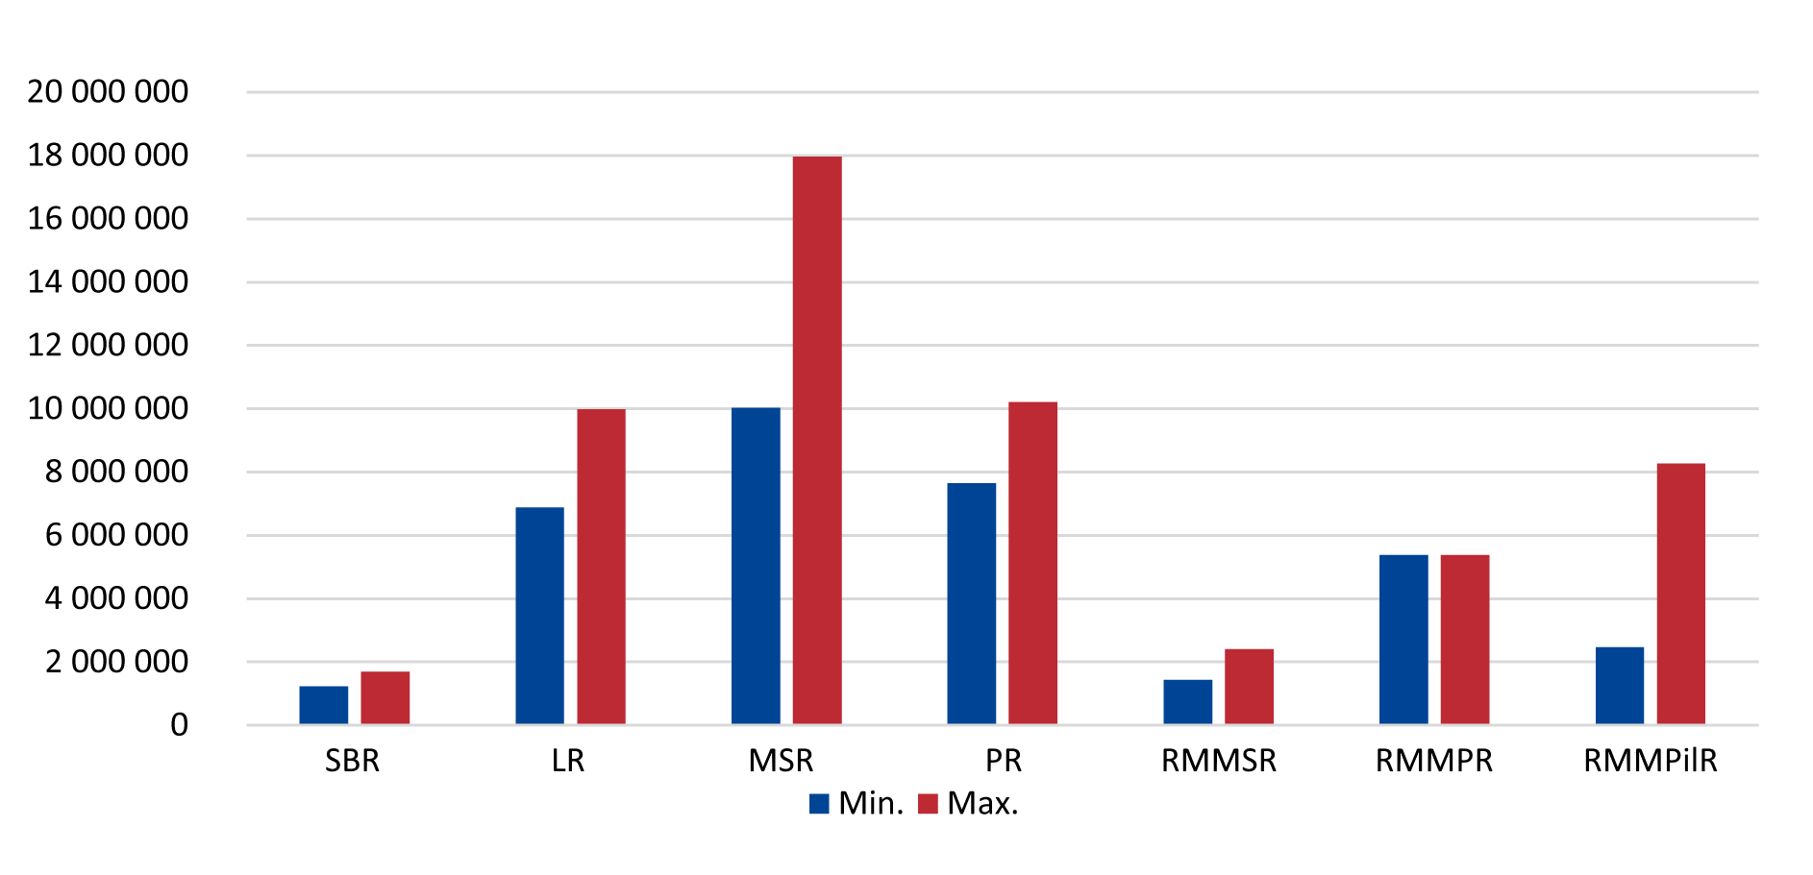
As can be seen from Table 3 and Chart 1, the SAO audit identified differences in unit costs for overall road surface repairs. The influences causing these differences included the conditions connected with the execution of the works, including the availability of the repaired section, the technical condition before the work commenced, the extent of the work carried out, the nature of the works, the period in which the work was performed, the competitive environment in the locality. Beneficiaries of the MSR and the PR implemented actions where there was a larger volume of earthworks.

Table 4 – Costs per 1 m² in the repairs and reconstruction of bridges
Beneficiary | Costs per 1 m² of repair of bridges (in CZK exclusive of VAT)
LR | 22,759.33
RMMPR | 58,811.60
RMMPilR | 12,936.80
Source: data obtained from the auditees.

The large differences in unit costs in the case of bridges were due to a different range of repairs and reconstructions and different types of bridge structures.

Also included in the audited projects were cases of the construction of new class II and class III roads. The costs of 1 km of newly built regional roads are shown in Table 5.

Table 5 – Costs per 1 km of new regional roads
Beneficiary | Costs per 1 km of newly built roads (in CZK exclusive of VAT)
 | Min. | Max.
SBR | 17,951,702.92 | 50,662,798.10
MSR | 50,918,542.86
Source: data obtained from the auditees.
Note: Within the MSR, one project was audited.

The unit costs for new road constructions were influenced by more impacts than in the case of overall repairs, as they included the construction of a new road body including activities not covered by overall repairs, such as demarcation, surveying, work with arable land and the construction of service roads.

The highest value of the road reconstruction costs associated with the flood damage removal was detected by the SAO audit in the case of the auditee RMMPR, where a II class road section of 489 m had been reconstructed at a cost of CZK 50,859,609.70 exclusive of VAT, which corresponded to the cost of 1 km in the amount of CZK 104,007,381.80 exclusive of VAT.

3. Comparison of estimated values of public contracts and winning bid prices

The SAO audit compared the expected values of public contracts, as set out in the public procurement budgets, usually using the ÚRS and other price lists and codebooks, with the bid prices of the winning tenderers. Table 6 lists the minimum and maximum proportions of the winning bids to the estimated values of public contracts for the individual auditees.

Table 6 – Proportions of winning prices to the expected values of public contracts
Beneficiary | Min. | Max.
SBR | 46 % | 118 %
LR | 72 % | 99 %
MSR | 38 % | 94 %
PR | 85 % | 97 %
RMMSR | 41 % | 101 %
RMMPR | 94 % | 100 %
RMMPilR | 48 % | 98 %
Source: data obtained from the auditees.

The situation is also illustrated by Chart 2.

Chart 2 – Proportion of the bid and the expected price of the public contract
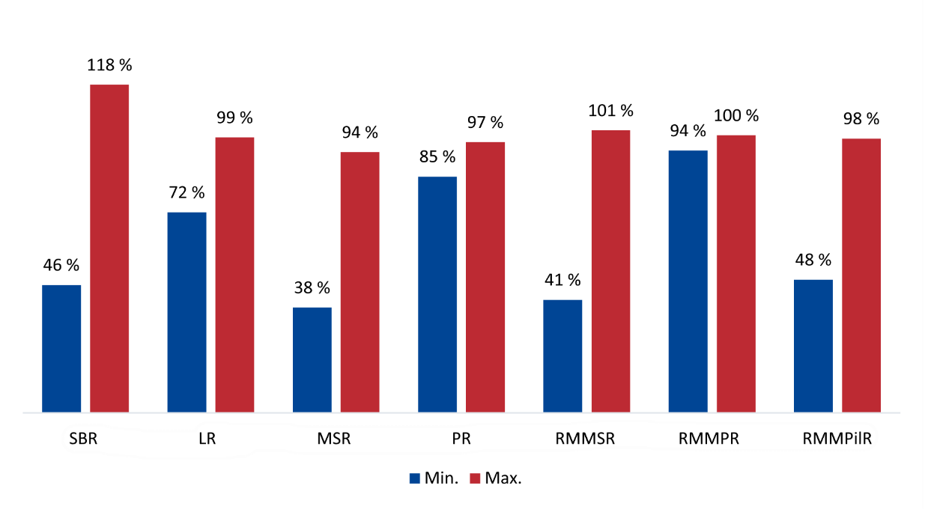
Significantly lower prices of the winning bids compared to the projected public contract values (in some cases by more than 50 %) had their cause, among others, in a competitive environment in the field of construction work. An exception to this result was a comparison performed for the auditees PR and RMMPR, where the prices of the winning bids for construction public contracts reached 85 % of the projected values. In one case of the construction public contract for bridge repair, the prices of all bids submitted (6 in total) were over 99 % of the estimated value of the public contract. On the other hand, for the beneficiary PR, 2 non-construction public contracts for the provision of services related to the administration of tenders were audited, where the winning bid prices reached 32 % and 29.5 % of the expected public contract values, and the difference between the highest and lowest bid prices reached 253 % and 436 %, respectively.

The SAO audit found that, in the vast majority of cases, the estimated value of public contracts had been determined by the designer using the price databases and codebooks of ÚRS and other processors. Given that the abovementioned codebooks and price databases usually contain price ranges for the valuation of materials and works, a sufficiently competitive environment is indicated not only by the value of the difference between the expected value of the public contract and the winning bid price, but also by the variance in the prices of all the tenders submitted.

Great differences between the minimum and maximum values ​​also indicate unsystematic work with the projected public contract values. Because the auditees left the determination of the estimated value to the processors of the project documentation in most of the cases audited, this practice led to different prices being used to determine the expected value of a public contract within the scope of the relevant codebook. Cases of a large decline in bid prices over the projected public contract values do not necessarily mean an economical use of funds, but may also point to an incorrectly determined value of the public contract.

4. Progress of repairs of the regional roads

The SAO audit evaluated, in cases where the data were available, the progress of repairing regional roads in the period under review and its continuity with the previous period.

In the case of class II and class III roads in the Pilsen Region, data were available from 2013, where the RMMPilR evaluated that 69 % of the total of 4,616 km of roads were in the unsatisfactory state or state of disrepair in the Pilsen Region. The gradual decrease in roads in the unsatisfactory state or state of disrepair is given in Tables 7 and 8, which show both the percentage and length data in km.

Table 7 – Class II and class III roads according to their condition in the Pilsen Region (in %)
Year | Road surface condition |  |  |  |  | Total
 | Excellent | Good | Satisfactory | Unsatisfactory | Disrepair
2013 | 10.0 | 9.0 | 12.0 | 23.0 | 46.0 | 100.00
2014 | 13.0 | 11.0 | 14.5 | 24.0 | 37.5 | 100.00
2015 | 16.0 | 13.0 | 17.0 | 25.0 | 29.0 | 100.00
2016 | 16.4 | 17.6 | 22.5 | 11.8 | 31.7 | 100.00
Source: data obtained from the auditees.

Table 8 – Class II and class III roads according to their condition in the Pilsen Region (in km)
Year | Road surface condition |  |  |  |  | Total
 | Excellent | Good | Satisfactory | Unsatisfactory | Disrepair
2013 | 461.700 | 415.530 | 554.040 | 1,061.910 | 2,123.820 | 4,617.000
2014 | 600.210 | 507.870 | 669.465 | 1,108.080 | 1,731.375 | 4,617.000
2015 | 738.560 | 600.080 | 784.720 | 1,154.000 | 1,338.640 | 4,616.000
2016 | 758.009 | 813.438 | 1,038.527 | 544.059 | 1,461.968 | 4,616.000
Source: data obtained from the auditees.

Tables 7 and 8 show that, in the period 2013-2016, the length of roads in the unsatisfactory state or state of disrepair in the Pilsen region decreased by 1,177 km, i.e. by 25.5 % of the total length of class II and class III roads in the Pilsen Region. The situation is illustrated by Chart 3.

Chart 3 – State of class II and class III roads in the Pilsen Region (in %)
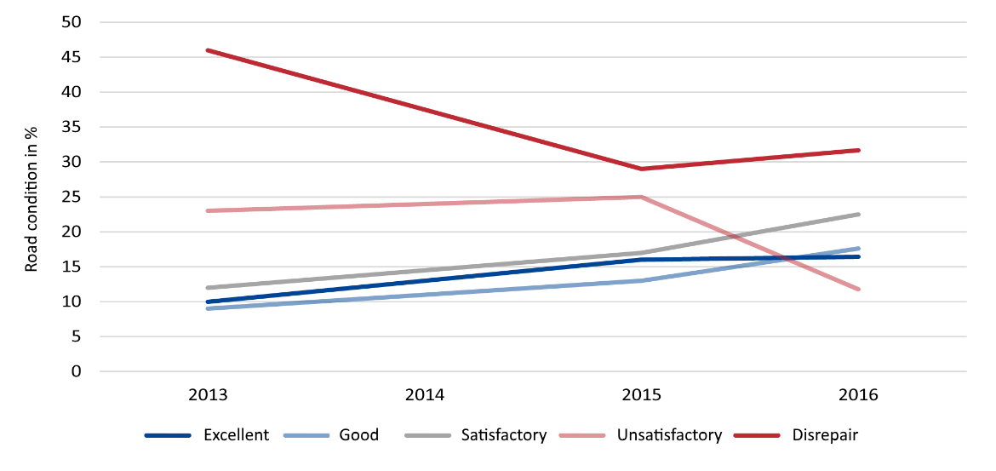
The situation in the Liberec Region in the same period 2013-2016 is documented in Tables 9 and 10, which show the results of road condition monitoring both in length units (km) and in percentage of the total length of class II and class III roads (about 2,077 km).

Table 9 – Class II and class III roads according to their condition in the Liberec Region (in %)
Year | Road surface condition |  |  |  |  | Total
 | Excellent | Good | Satisfactory | Unsatisfactory | Disrepair
2013 | 9.2 | 26.7 | 11.8 | 14.8 | 37.5 | 100.00
2014 | 7.9 | 28.0 | 12.7 | 14.2 | 37.2 | 100.00
2015 | 10.4 | 27.5 | 11.9 | 12.9 | 37.3 | 100.00
2016 | 13.0 | 26.7 | 12.7 | 17.2 | 30.4 | 100.00
Source: data obtained from the auditees.

Table 10 – Class II and class III roads according to their condition in the Liberec Region (in km)
Year | Road surface condition |  |  |  |  | Total
 | Excellent | Good | Satisfactory | Unsatisfactory | Disrepair
2013 | 190.748 | 554.159 | 245.938 | 306.471 | 779.823 | 2,077.139
2014 | 164.797 | 580.211 | 264.481 | 294.304 | 771.814 | 2,075.607
2015 | 214.904 | 570.792 | 247.702 | 267.731 | 775.521 | 2,076.650
2016 | 268.853 | 554.534 | 264.000 | 357.949 | 631.475 | 2,076.811
Source: Data obtained from the auditees.

The figures in the tables show that approximately 7 % of roads (145 km) classified as being in disrepair were repaired between 2013 and 2016. On the other hand, the length of roads in unsatisfactory condition grew by about 2.5 %, i.e. by 52 km. The overall sum of roads in the unsatisfactory state or state of disrepair improved by 4.6 %, i.e. by about 96 km. The situation is illustrated by Chart 4.

Chart 4 – State of class II and class III roads in the Liberec Region (in %)
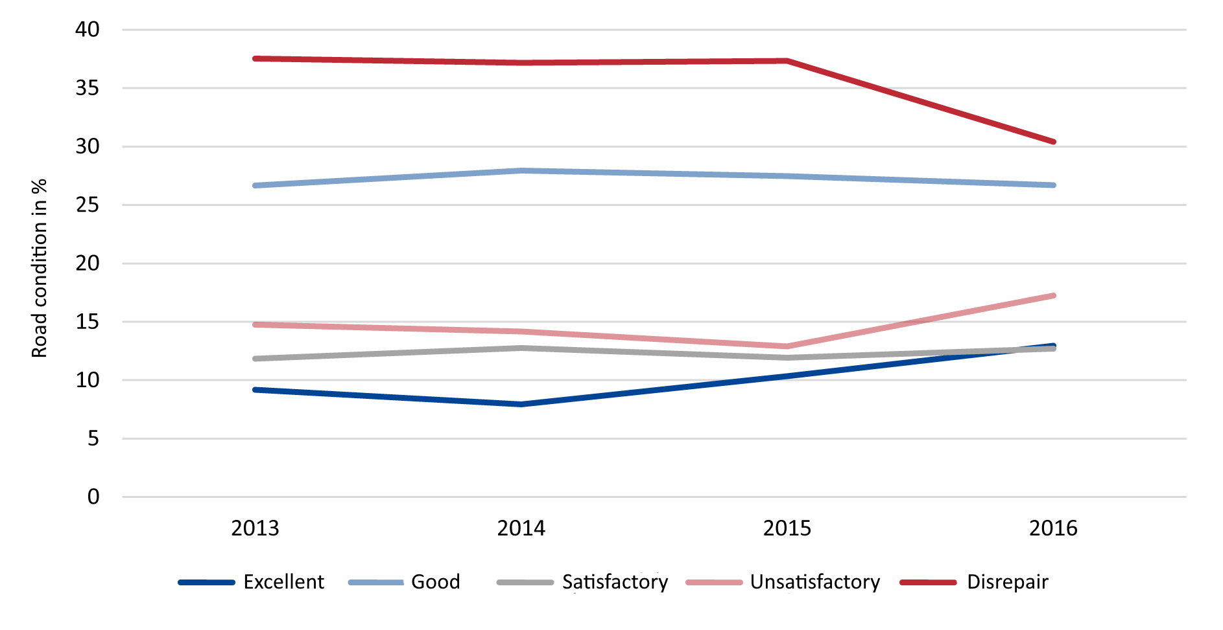
The condition of class II and class III roads in the Pardubice Region was monitored by the RMMPR. The PR conceptual document is the document entitled “Maintenance and development programmes for real property in the areas of transport, education, health, social affairs, culture and other” (hereinafter the “MDP in transport”), which set out basic objectives in the process of maintenance and development of real property of the PR for 2013-2017. The objective was to stabilise the decisive part of the backbone road network of the Pardubice Region by 2016. The PR had not set the projected number of km of the backbone network it had wanted to stabilise by 2016, so it had been unable to assess whether it had met the target. The PR further elaborated documents proving an increasing number of class II and class III roads in the unsatisfactory state or state of disrepair in the PR, and quantifying the financial difficulty of bringing these roads into a good structural and technical condition.
The data from 2016 show that a complete renovation of the road network including cyclical repairs within the ten-year planning period would include the financial need for class II roads in the PR in the amount of CZK 1.488 billion and for class III roads in the amount of CZK 7.092 billion.

5. Composition of funds

The SAO audit, where data were available, evaluated the amount of funds from resources used to repair regional roads in the period under review and in the preceding periods, a total for 2012-2016. The data are presented in tables and charts for the Liberec, Moravian-Silesian, Pardubice and Pilsen Regions.

Liberec Region

Table 11 – Funds contributed to class II and class III roads in the years 2012-2016 (in CZK million)
Year | Regional funds total | EU subsidy granted | SFDI subsidy | Total per year
2012 | 249.943 | 212.287 | 0.000 | 462.230
2013 | 310.457 | 307.107 | 36.370 | 653.934
2014 | 327.378 | 224.287 | 135.982* | 687.647
2015 | 195.892 | 704.767 | 197.996* | 1,098.655
2016 | 275.809 | 0.000 | 128.764 | 404.573
Total | 1,359.479 | 1,448.448 | 499.112 | 3,307.039
Source: data obtained from the auditees.
* These were purposefully provided funds for the removal of flood damage.

Chart 5 – Overview of funds by source – Liberec Region (in CZK million)
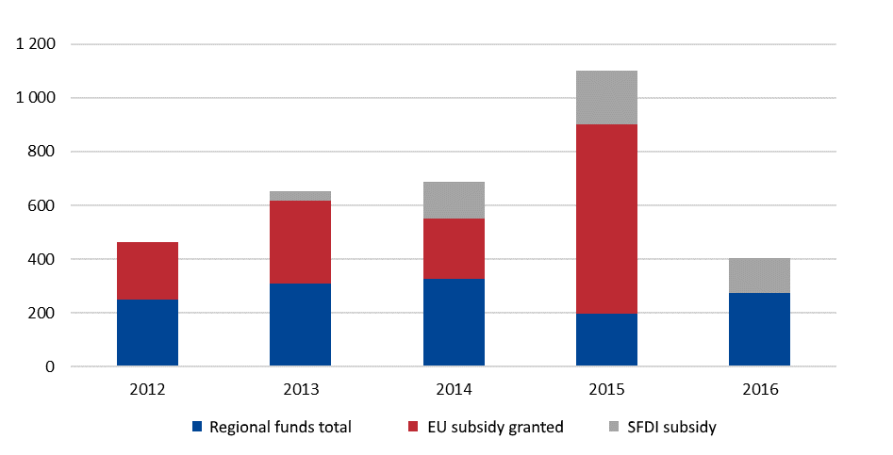
Moravian-Silesian Region

Table 12 – Funds contributed to class II and class III roads in the years 2012-2016 (in CZK million)
Year | Regional funds total | EU subsidy granted | SFDI subsidy | Subsidies from the Ministry for Regional Development | Total per year
2012 | 314.791 | 767.297 | 4.260 | 8.587 | 1,094.935
2013 | 284.877 | 602.527 | 37.651 | 0.000 | 925.055
2014 | 149.376 | 831.498 | 0.000 | 0.000 | 980.874
2015 | 199.795 | 970.454 | 247.280 | 0.000 | 1,417.529
2016 | 287.814 | 0.100 | 168.417 | 0.000 | 456.331
Total | 1,236.653 | 3,171.876 | 457.608 | 8.587 | 4,874.724
Source: data obtained from the auditees, data on the EU subsidies were obtained from the website of the Regional Council of the Northeast Cohesion Region.

Chart 6 – Overview of funds by source – Moravian-Silesian Region (in CZK million)
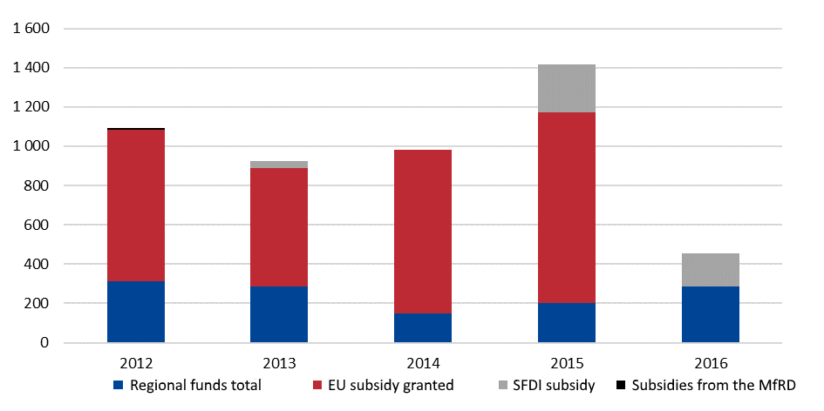

Pardubice Region

Table 13 – Funds contributed to class II and class III roads in the years 2012-2016 (in CZK million)
Year | Regional funds total | EU subsidy granted | SFDI subsidy | Total per year
2012 | 383.737 | 255.916 | 0.000 | 639.653
2013 | 393.886 | 0.000 | 0.000 | 393.886
2014 | 439.862 | 544.709 | 0.000 | 984.571
2015 | 447.937 | 186.063 | 285.068 | 919.068
2016 | 554.762 | 0.000 | 196.696 | 751.458
Total | 2,220.184 | 986.688 | 481.764 | 3,688.636
Source: data obtained from the auditees.

Chart 7 – Overview of funds by source – Pardubice Region (in CZK million)
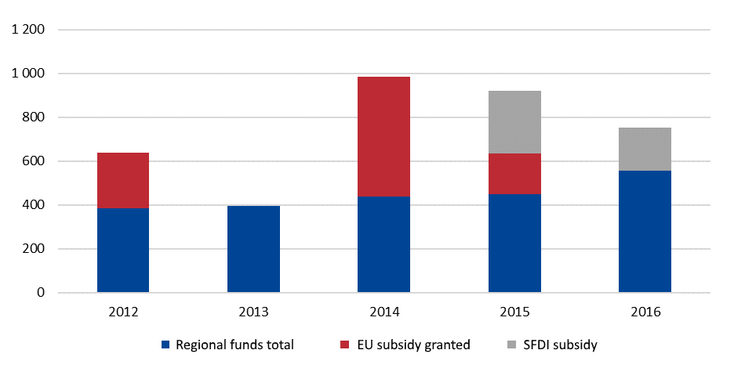

Pilsen Region

Table 14 – Funds contributed to class II and class III roads in the years 2012-2016 (in CZK million)
Year | Regional funds total | EU subsidy granted | SFDI subsidy | Total per year
2012 | 259.000 | 764.000 | 0.000 | 1,023.000
2013 | 68.000 | 939.000 | 92.000 | 1,099.000
2014 | 77.000 | 773.000 | 0.000 | 850.000
2015 | 129.000 | 449.000 | 394.000 | 972.000
2016 | 395.000 | 0.000 | 317.000 | 712.000
Total | 928.000 | 2,925.000 | 803.000 | 4,656.000
Source: data obtained from the auditees.

Chart 8 – Overview of funds by source – Pilsen Region (in CZK million)
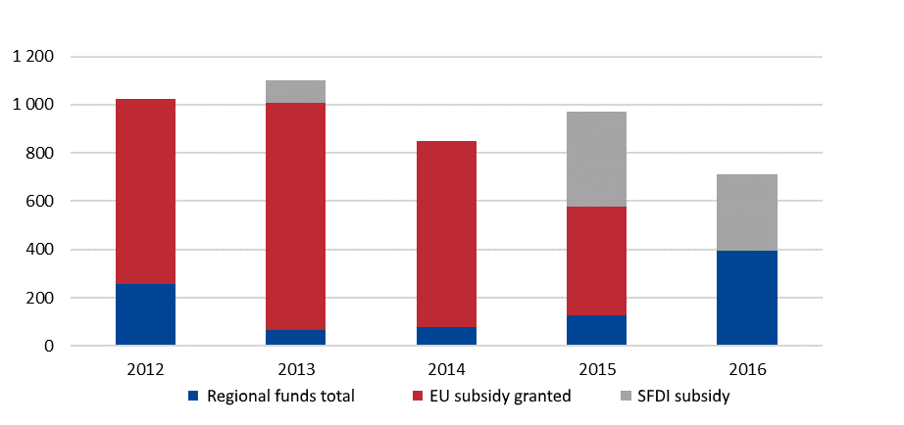

From the above data it is clear that for the period 2012-2016, most funds were put into its roads by the Moravian-Silesian Region, totalling CZK 4.87 billion, of which CZK 1.24 billion (i.e. 25.5 %) came from the regional funds. In the same period, the Liberec Region put the least amount of funds into its roads, totalling CZK 3.31 billion. The share of own funds in the region of CZK 1.36 billion was 41.1 % for the Liberec Region.

The largest share of own funds was put in class II and class III roads by the Pardubice Region. In the given period, its share was 60.2 %. By contrast, the smallest share of own funds was spent by the Pilsen Region in the period 2012-2016, i.e. 19.9 %.

Annex 1

Comparison with the results of a similarly focused audit carried out by the SAO SR in 2014

The Supreme Audit Office of the Slovak Republic carried out an audit in 2014 focused on the processes related to the maintenance, repair and development of networks of class II and class III roads managed by higher territorial self-governing units in Slovakia (hereinafter “SR”). The period under review was 2010-2012 with a possible overlap in the context of previous or subsequent periods. The auditees were all regions and organisations established by them, which carried out maintenance, repairs and development of class II and class III roads. The Summary Report entitled Summary report on the outcome of the audit of the economy, efficiency and effectiveness of the funds spent on the construction, repair and maintenance of the roads managed by HTU and the tasks resulting for the HTU therefrom was prepared and published after the audit, and the comparison uses the data provided in that Summary Report.

1. Area of expenditure and costs of class II and class III roads

The main benchmark was the cost of repairs and reconstruction of 1 km of regional roads, which, according to the Summary Report, reached values from approximately EUR 70,000 to EUR 230,000 for Slovak regions, as can be seen from Chart 9. At the exchange rate of CZK 25/EUR 1, these prices expressed in Czech crowns are between CZK 1,750,000 and CZK 5,750,000.

Chart 9 – Average costs of reconstruction of 1 km of class II and class III roads in thousands of euros – Slovakia
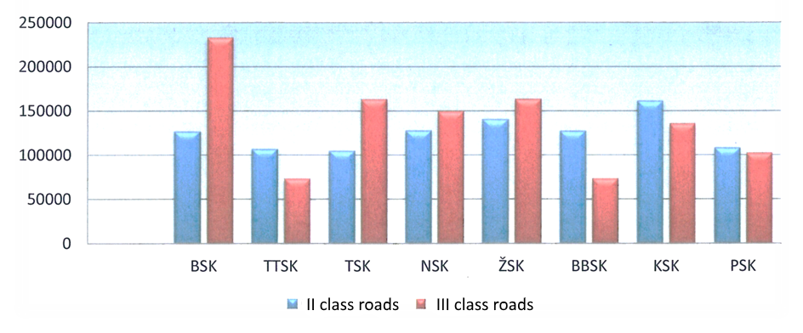
Source: Summary report on the outcome of the audit of the economy, efficiency and effectiveness of the funds spent on the construction, repair and maintenance of the roads managed by HTU and the tasks resulting for the HTU therefrom, SAO of the Slovak Republic 2014.

Explanatory notes:
BSK – Bratislava self-governing region, TTSK – Trnava self-governing region, TSK – Trenčín self-governing region, NSK – Nitra self-governing region, ŽSK – Žilina self-governing region, BBSK – Banská Bystrica self-governing region, KSK – Košice self-governing region, PSK – Prešov self-governing region.

The SAO CR audit found average values from about CZK 1,470,000 to CZK 14,000,000 for the auditees in the period under review, see Table 15.

Table 15 – Costs per 1 km of repaired roads
Beneficiary | Costs per 1 km of overall road repairs (in CZK exclusive of VAT)
 | Min. | Max. | Diameter*
SBR | 1,227,844.76 | 1,687,526.60 | 1,472,978.41
LR | 6,872,612.18 | 9,987,354.43 | 8,357,246.69
MSR | 10,025,919.32 | 17,965,641.85 | 13,995,780.58
PR | 7,643,007.25 | 10,216,177.78 | 8,929,592.51
RMMSR | 1,425,266.16 | 2,407,256.41 | 2,039,613.09
RMMPR | 5,379,030.37 | 5,379,030.37 | 5,379,030.37
RMMPilR | 2,455,476.86 | 8,274,386.76 | 5,037,650.71
Source: data obtained from the auditees.
* The average values were calculated for all the audited projects of the auditee in question.

The spread of the cost of repairs and modernisation of 1 km of regional roads in the Czech Republic and Slovakia is partly due to the fact that the data from the SR are presented in the form of average values for the whole individual regions, while in the case of the Czech Republic only for 23 actions in 5 regions; a certain impact is also caused by similar effects reported by the colleagues from the SAO SR in their Summary Report, for example the comparison does not take into account sections with different parameters of fragmentation, in some cases with newly built connections to existing roads, with different requirements for the rehabilitation of the base layers etc.

New road sections, rehabilitation of flood damage and repairs of bridge objects were not included in the comparison, as they were not included in the cost calculation in the SAO SR Summary Report. A graphical representation of costs is shown in Chart 10.

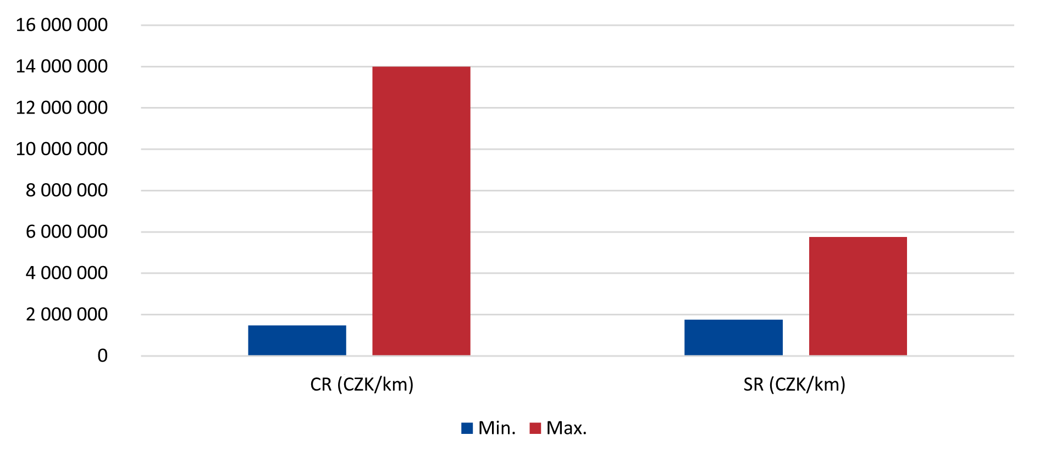
Chart 10 – Comparison of average costs of reconstruction of 1 km of class II and class III roads in the Czech Republic and Slovakia

2. Area of funding sources

The comparison of the sources of financing showed a different situation between the Czech Republic and Slovakia both in the area of subsidies and in the area of own funds of regions. The situation in the Slovak Republic is shown in Chart 11, which shows that the largest share of funding for regional roads (including summer and winter maintenance) can be attributed to own funds. These include the tax on motor vehicles, which constitutes the income of regions in the SR. The EU subsidies accounted for 27 % of the funds spent on regional roads in the period under review.

Chart 11 – Structure of sources of financing in the Slovak Republic in 2010-2012
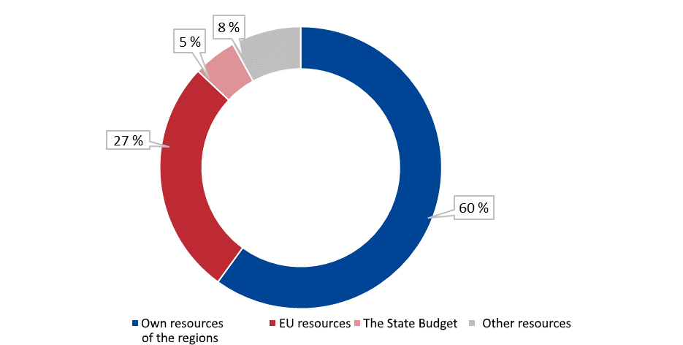

The situation in the Czech Republic was not audited in nationwide terms, therefore the structure of sources of funds spent on repairs and modernisation of the regional roads constitutes a sum for 4 regions – the Liberec, Moravian-Silesian, Pardubice and Pilsen Regions, i.e. regions from which data were collected for the whole region. It can be seen from Chart 12 that almost ⅔ of the funds spent came from subsidies from the EU (51.6 %), the SFDI (13.5 %) and the Ministry for Regional Development (0.1 %). The regions’ own resources covered 34.8 % of the expenditure.

These sums did not include funds spent on summer and winter road maintenance, which was not subject to Audit No. 17/09.

Chart 12 – Structure of sources of financing in 2012-2016 – selected regions of the Czech Republic
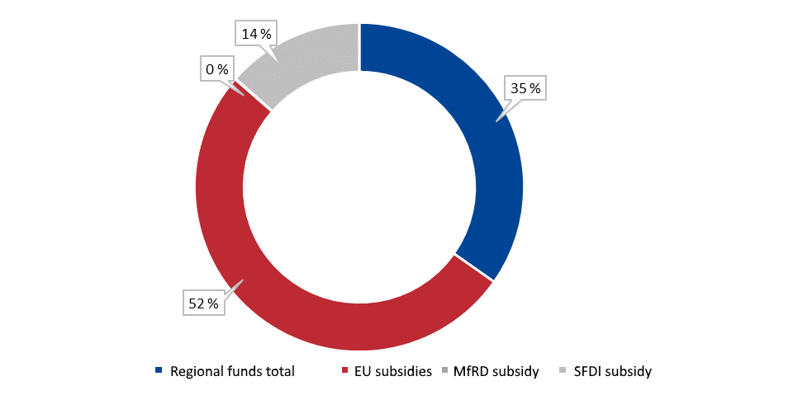

3. State of class II and class III roads

In the period 2010-2012, 60 % of the costs of reconstruction and maintenance of class II and class III roads were covered in the SR from the regions’ own resources. The EU funds covered 27 % of the expenditure, and the remaining 13 % were covered from the state budget and other sources. The structure of resources in the audited regions in the Czech Republic was different; the largest part of the expenditures amounting to 51.6 % was covered by the EU subsidies, 13.6 % were covered by subsidies from the state budget, and the regions’ own resources covered 34.8 % of the expenditure. Subsidies thus covered nearly ⅔ of the expenditure on repair and modernisation of class II and class III roads. This result shows the efforts of the regions in the Czech Republic to use the EU resources to improve the state of the roads.

However, the results of the audit as regards improving the percentage of roads in good technical condition are not convincing in all cases. Progress was identified in the Pilsen Region, while the improvement in the Liberec Region was minimal in the period under review (see Chapter IV(4) of this Audit Conclusion). Given that the EU subsidies have been and are limited in time, it should be in the interest of the regions to use these resources to put their roads in good shape in the shortest possible time. Their own limited funds would then be better spent on repairs and maintenance.

The SAO SR stated in its Summary Report that, from the nationwide point of view and in relation to the amount of funds spent on the reconstruction of class II and class III roads in the individual regions, spending these funds did not seem to be the most efficient, as the state of the roads in 2013 had not differed fundamentally from the situation in 2004. The situation in the SR is documented in Charts 13 and 14, separately for class II and class III roads.

Chart 13 – Overview of state of class II roads – Slovakia
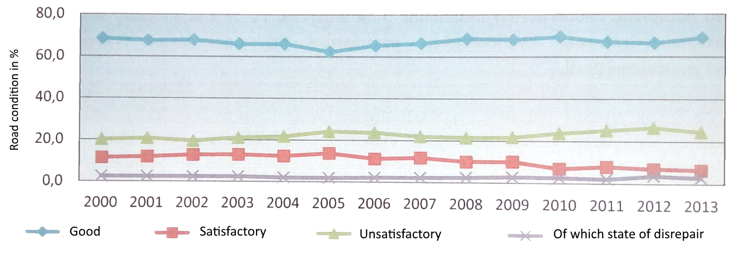

Source: Summary report on the outcome of the audit of the economy, efficiency and effectiveness of the funds spent on the construction, repair and maintenance of the roads managed by HTU and the tasks resulting for the HTU therefrom, SAO of the Slovak Republic 2014.

Chart 14 – Overview of development in the state of class III roads – Slovakia
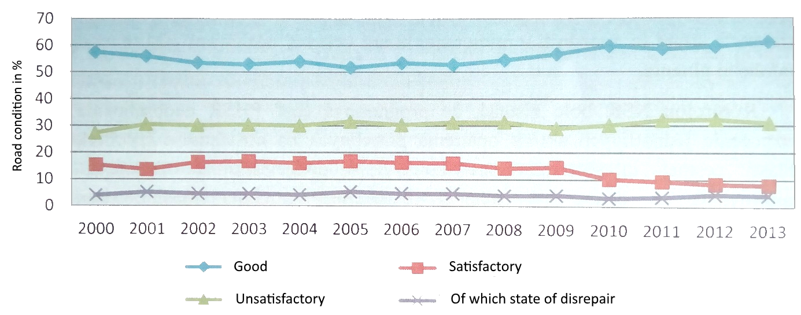

Source: Summary report on the outcome of the audit of the economy, efficiency and effectiveness of the funds spent on the construction, repair and maintenance of the roads managed by HTU and the tasks resulting for the HTU therefrom, SAO of the Slovak Republic 2014.

4. Public procurement

The SAO CR audit identified cases of minor breaches related to public procurement. The issue concerned determining the estimated value of public contracts and the conclusion of amendments to agreements with contractors in the case of additional and cancelled work.

Similar findings are given by the SAO SR in its Summary Report; in addition to the problems with establishing the estimated value of the contract, it identified cases of conclusion of an agreement with a price different than the winning bid, exclusion of tenderers from the competition without giving any reason, a late release of the security, and entering into amendments to agreements for activities which had not been the subject-matter of the original contract without a tendering procedure.

Annex 2

Database of data on bridge objects on class II and class III roads
audited under Audit No. 17/09

The database of data on 5 bridge objects on class II and class III roads whose repairs and reconstructions were audited under Audit No. 17/09 contains data on the construction works executed, financial costs, selected technical data on the given bridge and the 10 most important items of the winning bid budget in the procurement procedure for the contractor. Further information on the aforesaid bridges can be found in the Bridge Management System at www.bms.vars.cz or www.bms.clevera.cz.

The database has been published on the SAO website at:
http://data.nku.cz/download/vystupy-z-kontrol/ka-17-09/databaze-udaju-mosty.xlsx.

Bridge objects in the database:

1. Bridge reg. No. 230-007 Stod on road No. II./230
Total repair costs: CZK 2.3 million exclusive of VAT.

2. Bridge reg. No. 30516-2 Radhošť – Janovičky on road No. III./30516
Total repair costs: CZK 8.8 million exclusive of VAT.

3. Bridge reg. No. 286-027 Vítkovice on road No. II./286
Total repair costs: CZK 2.1 million exclusive of VAT.

4. Bridge reg. No. 286-031 Vítkovice on road No. II./286
Total repair costs: CZK 4.4 million exclusive of VAT.

5. Bridge reg. No. 459-006 Krnov on road No. II./459
Total repair costs: CZK 6.2 million exclusive of VAT.

List of abbreviations used

3E Principles of efficiency, effectiveness and economy
AR CR Association of Regions of the Czech Republic
CC MT Central Committee of the Ministry of Transport
CR (Czech Republic) Czech Republic
EU European Union
SBR South Bohemian Region
Audit SAO audit
LR Liberec Region
MfRD Ministry of Regional Development
MSR Moravian-Silesian Region
SAO Supreme Audit Office of the Czech Republic
SAO SR Supreme Audit Office of the Slovak Republic
PR Pardubice Region
SFDI Rules Rules for financing programmes, constructions and actions from the budget of the State Fund for Transport Infrastructure
CDP CR Chamber of Deputies of the Parliament of the Czech Republic
MDP in transport Maintenance and development programmes for real property in the areas of transport, education, health, social affairs, culture and other (conceptual material of the Pardubice Region)
ROP Regional Operational Programme(s)
RC Regional Council of the Cohesion Region
RCSW Regional Council of the Southwest Cohesion Region
SFDI State Fund for Transport Infrastructure
Regional roads Class II and class III roads in selected regions
Agreement Agreement to provide funding from the SFDI budget
SR Slovak Republic
RM Road Management
RMMSR Road Management of the Moravian-Silesian Region, public-benefit corporation
RMM Road Management and Maintenance
RMMPR Road Management and Maintenance of the Pardubice Region, public-benefit corporation
RMMPilR Road Management and Maintenance of the Pilsen Region, public-benefit corporation
OPC Office for the Protection of Competition
HTU Unit of territorial self-government in Slovakia (from Slovak: higher territorial unit)
Contract Public contract within the meaning of Act No. 137/2006 Coll., on Public Procurement
FEA Final Evaluation of the Action
Public Procurement Act Act No. 137/2006 Coll., on Public Procurement

Act No. 104/2000 Coll., on the State Fund for Transport Infrastructure.
Act No. 132/2000 Coll., on the amendment and abolition of some laws related to the Act on Regions, the Act on Municipalities, the Act on District Authorities, and the Act on the City of Prague.
Act No. 13/1997 Coll., on Roads.
Act No. 248/2000 Coll., on Support to Regional Development.
Act No. 250/2000 Coll., on the Municipal Budgetary Rules.
See https://www.nku.gov.sk/documents/10157/b4b3b0ec-5056-40ed-9316-0c8b95aaf5f6.
The Road Management System is a system for optimising lifecycle maintenance costs, the main benefits of which are the economy, transparency and control of the use of funds for road maintenance and repairs.
Act No. 137/2006 Coll., on Public Procurement.
Audit Conclusion of Audit No. 09/26 – Funds designated under Regional Operational Programmes for transport infrastructure projects, published in 1/2011 of the SAO Journal.
The Bridge Management System is an expert system with nationwide competence, which is used to record bridges, passes (in the future also tunnels) for all road managers, to assess bridge structures in terms of their condition, loadability and usability, and to determine the necessary maintenance, repairs or reconstruction. The system is the result of a research and development project funded by the Ministry of Transport and was created by the “PONTEX VARS-Viapont Association”.

