Audit Conclusion

18/20

State funds earmarked for the crime prevention

The audit was included in the Supreme Audit Office's Audit Plan (hereinafter referred to as ‘SAO’) for 2018 under the number 18/20. The audit was conducted and the Audit Report was elaborated by the SAO Member Mr. Jan Stárek.

The objective of the audit was to examine the provision and use of state funds designated for crime prevention and to check whether the provided support contributed to the fulfilment of objectives in this area.

The audit was carried out from September 2018 to February 2019.

The audited period was from the year 2015 to 2018, and in the case of factual context, also the preceding and following periods.

Audited entities:
The Ministry of the Interior (hereinafter ‘MoI’), the Ministry of Justice (hereinafter ‘MoJ’), and the Ministry of Defence (hereinafter ‘MoD’), Ratolest Brno (non-governmental, non-profit organization) and the following Czech cities and towns: České Budějovice; Vimperk; Lomnice nad Lužnicí; Brno; Břeclav; Mimoň; Ralsko; Velké Hamry; Kladno; Příbram; Slaný; Dolní Poustevna; Jirkov, Most; z.s.

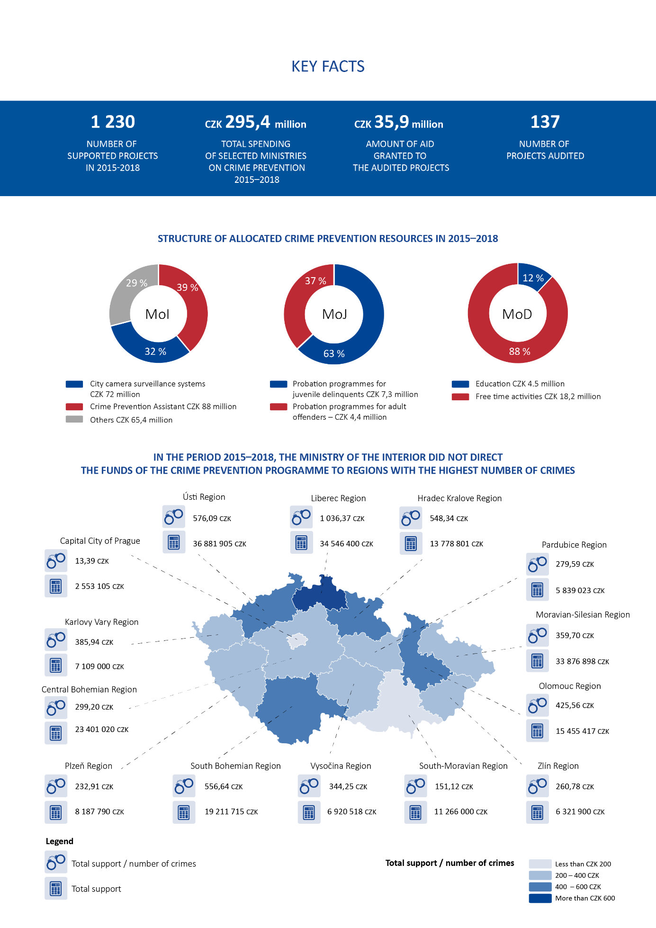

I. Summary and Evaluation
The SAO carried out an audit of funds intended for crime prevention in order to verify the provision, use and benefits from support provided to meet the objectives in this area.
The MoI, MoJ and MoD did not mostly set measurable targets that are supposed to be achieved when providing support for crime prevention.
The MoI, MoJ and MoD also did not set measurable indicators for the evaluation of individual projects in the provision and use of funds. Thus, the currently set system does not allow to quantify the benefits from support provided to meet the objectives of crime prevention. The SAO did not identify that the providers of funds used founds for other purposes than those specified in the program documentation.

The SAO found during the audit the following:
- The MoI has taken over the objectives and priorities of strategic crime prevention into the documents of the Local Crime Prevention Programme (the PK Programme) only generally and has not set expected benefits from the support provided. The MoJ did not create a sectoral crime prevention strategy and did not set measurable targets and expected benefits from the support provided . In the 2015 –2019 Concept of Primary Prevention of Risk Behaviour of the Ministry of Defence Staff, the MoD set only general objectives and priorities, without measurable expected benefits.

- The MoI and MoJ did not define unified measurable criteria and indicators of success in their decisions awarding grants, which would enable to evaluate the expected benefits of the provided support. The beneficiaries themselves set the criteria and indicators of success in their subsidy applications, but often not measurable. But even when criteria had been set measurable, they were often evaluated only verbally without using measurable data after project implementation.

- During the audited period, the MoJ did not support two of the five funding priorities (Programmes for Dangerous Drivers and Programmes for Increasing Parental Responsibility) of the Grant for Development of Probation and Resocialization Programmes for Adult Offenders ("PRDP"). One of the causes was the low MoJ activity aimed at promoting programmes. At the same time, due to low applicants' interest in supported priorities, the MoJ approved all submitted grant applications and at the same time provided most of the support for two projects implemented by the same non-profit organization.
- The MoI, MoJ and MoD did not evaluate the benefits of supporting crime prevention programmes. The reason was the absence of specific measurable anticipated results and uniform criteria and indicators of success.
- The MoI did not direct the funds of the PK Programme to regions with the highest number of crimes per thousand inhabitants or the highest risk index of regions.. The MoJ did not reach the planned number of clients involved in about half of the probation programme projects. The MoD spent the vast majority of funds from the Crime Prevention Programme on leisure activities as sporting and cultural activities. . Only one-eighth of their volume was devoted to educational activities.
The SAO recommends that:
- The MoI and the MoD set measurable targets for crime prevention programmes which they expect to achieve;
- The MoJ create a sectoral strategic crime prevention document and set measurable goals that it anticipates to achieve
- The MoI, MoJ and MoD set uniform measurable criteria and indicators of project success, which will enable quantification and evaluation of the achieved benefit of the provided support;
- The MoJ take steps to increase interest in unsupported probation programme priorities;
- The MoI, MoJ and MoD evaluate the provided support against the set objectives of subsidy programmes through uniform measurable criteria and indicators of success.

Annex No. 1 - Selected answers for the questionnaire survey on the European Supreme Audit Institutions in the area of crime prevention
SAI | Are crime prevention targets set in your country? | Are there any strategies or concepts adopted in this area? | Are there defined objectives and expected measurable results of provided aid for crime prevention programmes in your country? | How are these objectives and expected results set? | How are crime prevention programmes evaluated in your country? | Is the effectiveness of undertaken projects evaluated?
Czech Republic | General objectives such as providing assistance and counseling to victims of crime, focusing on the growing problem of criminal recidivism and resocialization of offenders or preventing crime of children and youth, addressing increased crime in selected locations. | Crime Prevention Strategy in the Czech Republic for 2016 to 2020, Crime Prevention Action Plan for 2016 to 2020, documentation and program policies. | The priorities and tasks are set out in the Action Plan. A total of 5 strategy priorities, 79 tasks and related activities. Tasks are defined as, for example, implementing the subsidized “Crime Prevention Programme or providing and strengthening support for the "Crime Prevention Assistant" project. | Objectives include, for example, reducing crime rate, reducing committing crimes, increasing the risk that the offender will not be caught.  The expected results of the investment projects are e.g. (number of CCTV systems) for non-investment projects these are non-measurable targets (e.g. increasing the sense of security, reducing recidivism). | Annual evaluation of the Crime Prevention Strategy and Action Plan. The crime prevention program is evaluated at the end of the programming period (2020). Continuous fulfillment of partial tasks set out in the Action Plan is evaluated. | Effectiveness is assessed through indicators that are set independently by the beneficiaries and are not uniform. Thus, the system does not allow quantifying the benefits of support to crime prevention objectives. The evaluation of the benefits of the support is foreseen at the end of 2019 through the uniform monitoring of project impacts.

Estonia | Measurable objectives on strategical level are set in the Guidelines for Development of Criminal Policy and in the Internal Security Development Plan 2015-2020. | The Internal Security Development Plan (ISCD) 2015-2020, in more detail the Safer Communities Programme | All ISCD’s programmes have defined objectives and measurable results. The Ministry of the Interior prepares a yearly report for the government on the implementation of the ISCD’s programmes. | The measurable goals usually concentrate on the output of the activities and not on the impact of certain activities or objectives as it is easier to measure output than impact. The expected impact is usually based on evidence-based assumptions, except in case of goals concerning public awareness. | The Ministry of the Interior prepares a yearly report for the government on the implementation of the ISCD 2015 – 2020. | Most of the crime prevention programmes introduced in Estonia and supported by public funds are evidence-based programmes originally developed and tested in other European countries. The efficiency is measured by researchers or public bodies as a part of adaption process.
Lithuania | General objectives: improving the coordination mechanism for the prevention of criminal acts and offenses; strengthening the role of municipalities by gradual decentralisation, reducing opportunities for cybercrimes. | Public Security Development Programme for the years 2015-2025, which includes the National Crime Prevention and Control Programme | Interinstitutional Action Plan for the Implementation of the Public Security Programme indicates implementing institutions, specific criteria for assessment of objectives and tasks of programme´s implementation. | Exact values for each planned year, for instance “to improve the efficiency of criminal acts and offences prevention” with the following assessment criteria as a number of offences per 100 thousand of residents; police response (arrival), number of killed persons per 100 thousand of residents, etc.. | The Ministry of the Interior monitors the implementation and effectiveness of the Public Security Programme. | closer unspecified
Finland | Reducing crime and its harmful effects and crime prevention. | The National Crime Prevention Programme for 2016 – 2020. | The programme has five main objectives and it includes a total of 29 measures to improve local crime prevention. | The programme aims to improve local crime prevention and to promote the participation of residents in local activities. | Annual monitoring,  there is also a database on Finnish evaluation research on crime prevention in place covering both process evaluations as well as impact evaluations. | The applicants must assess e.g. the effectiveness of the results and present a plan of the evaluation of the project in their application.
Poland | Strategic objectives are e.g. “to ensure high level of security and public order.“ | Government´s “Programme for Prevention and Combat of Economic Crime for 2015-2020”, Crime and Anti-Social Behaviour Limiting Programme Safer Together for 2018-2020, The Programme for Prevention of Crime Causes for 2019-2023. | The objectives are set out in specific projects through grant agreements without measurable results. | Defined by general activities such as organizing and implementing information campaigns and projects, R&D work, distribution of publications, expanding the crime victim support network, etc. | The Centre for Public Opinion Research conducts annual studies to examine the sense of security amongst Poles. After the completion of the ex-post evaluation is conducted. | The Programme is analysed, its achievement reviewed, its results are assessed and areas to be improved are identified.
Source: survey results.

The obligation to elaborate a departmental crime prevention strategy follows from Resolution No. 66 of the Government of the Czech Republic of 25 January 2016, on the Crime Prevention Strategy in the Czech Republic for 2016 to 2020.
The MoD provided support for crime prevention from its own budget.
The risk index of regions is based not only on the crime rate, but also depends on the number of unemployed or the number of social benefits paid in the region.
Pursuant to Article 59 of Act No. 221/1999 Coll., On Professional Soldiers.

